PART C Q1. Diagnose Network Connectivity Issues
Problem Statement
Given a network topology with a router (R1), a switch (S1), and multiple VLANs, identify and resolve basic network connectivity issues. Ensure devices within the same VLAN can communicate and verify the configuration of IP addressing, including DHCP settings for each VLAN.
OUTPUT & CONFIG:
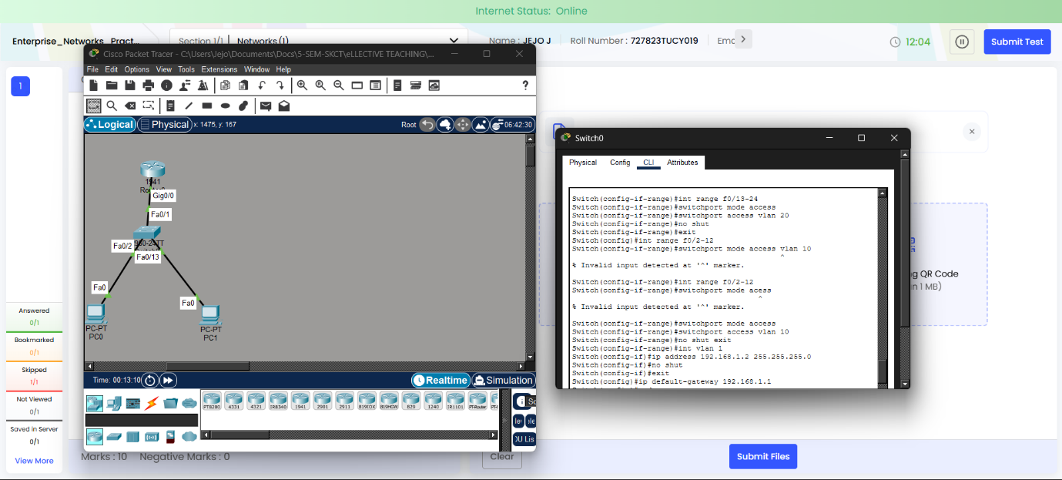
Ping result:
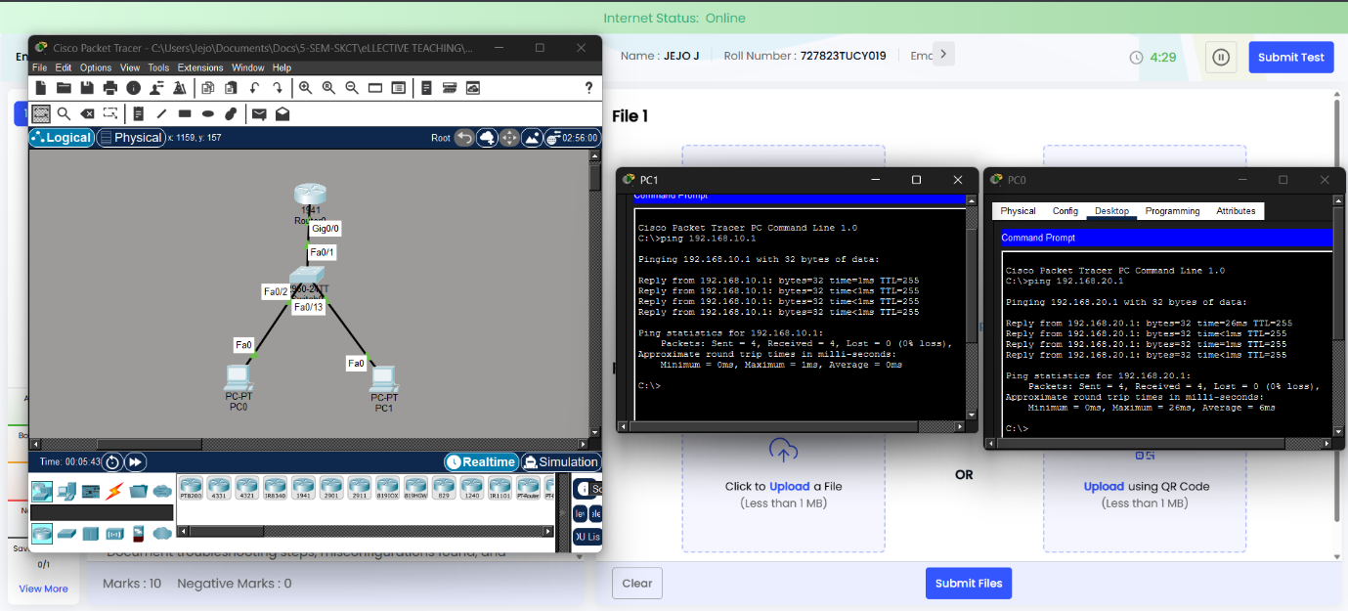

Name: Jejo J
Roll: 727823tucy019

